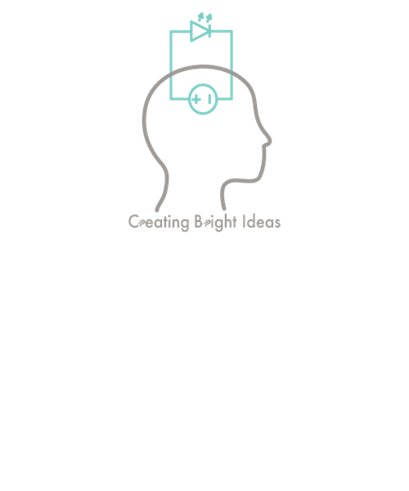

August 6, 2018

605.601.83.SU18

Foundations of Software Engineering

Software Design Document

jennifer Walker;fiona lyons;kevin hicks

Contents

2 Introduction 3

2.1 Purpose 3

2.2 Scope 3

2.3 Definitions, Acronyms, Abbreviations 3

3 UML Class Diagram 3

3.1 Wheel of Jeopardy Class Diagram 3

3.2 Specific Class Details 4

4 Activity Diagrams 6

4.1 Start Game Activity Diagram 6

4.2 Switch Rounds Activity Diagram 7

4.3 Category Selection Activity Diagram 9

4.4 Free Turn Activity Diagram 10

# Introduction

## Purpose

The purpose of this document is to provide documentation that will describe the design for the computer version of the Wheel of Jeopardy game. This documentation will provide details in graphical, written, and tabular form for how the software should be built.

## Scope

This document will address the following:

* A class diagram which will show the classes implemented into this design and their connections (e.g., associations, aggregations, and specializations)
* Documentation of the attribute operations for each identified class and the connections between those classes
* Activity diagrams that document the interactions between objects of the identified classes

## Definitions, Acronyms, Abbreviations

A glossary containing relevant definitions, acronyms, and abbreviations will be provided as a separate document

# UML Class Diagram

## Wheel of Jeopardy Class Diagram

The classes necessary for the Wheel of Jeopardy design are listed as follows:

* Controller
* Player
* Game
* Wheel
* Slice
* Board
* Category
* Question

The diagram below displays the attributes and operations of each class as well as the connections between each class. Following sections will go into further detail of these aspects of the class diagram.

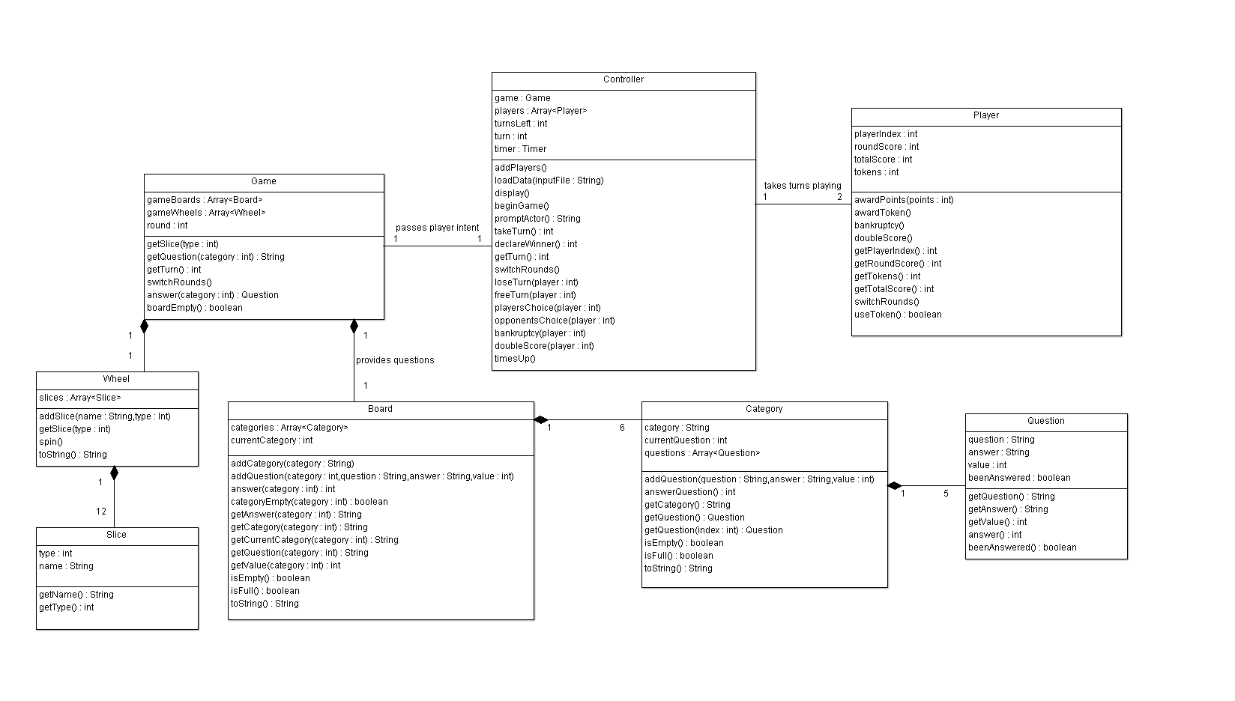

Figure 1 Wheel of Jeopardy UML Class Diagram

## Specific Class Details

|  |  |  |
| --- | --- | --- |
| **Class** | **Class Description** | **Class Interactions** |
| Controller | * Handles display responsibilities and the major flow of control * Initializes player and game instances * Handles/loads user input and communicates it to player and game instances * Selects the appropriate courses of action dependent on player and game instances * Reads in input question data * Starts/stops question timer | The Controller class directly interacts with the Game class and Player class. The Controller class communicates player intent to the Game class and which player’s turn it is to the Player class. |
| Player | * Represents a player in the game * Stores player information such as score and token status * Increases or decreases score based on appropriate game instances | The player class directly interacts with the controller class. |
| Game | * Composite class which contains one Wheel instance and one Board instance * Responsible for facilitating the actions necessary to switch rounds and end the game * Tracks current player, turns taken, round, and board status in regards to how many questions are left. * Loads in new questions into Board | The Game class interacts with the Wheel, Board, and Controller classes to communicate wheel instances, questions, and player intent respectively. |
| Wheel | * Composite class which contains Slice instances * Represents the Wheel of Fortune board * Selects slice when wheel is spun, awards tokens | The Wheel class interacts with the Game class and Slice class to communicate wheel instances and retrieve slice data. |
| Slice | * Represents a slice on the wheel * Contains type data, such as a question category, or special game instance (i.e., lose a turn, bankruptcy, etc…) | The Slice class provides the data type of the slice to the wheel class. This is the Slice class’s sole interaction. |
| Board | * Composite class which contains Category instances * Represents Jeopardy board * Selects category * Prompts user for an answer * Determines if board is empty | The Board class interacts with the Game class and the Category class. The Board class provides questions to the Game class and contains categories from the Category class |
| Category | * Composite class which contains Question instances * Tracks which question is next and which have been answered | The Category class provides the categories that are contained within the Board class and contains the questions provided from the Question class |
| Question | * Contains question, answer, and point value data | The Question class solely interacts with the Category class by providing the questions that the Category class contains |

Table Wheel of Jeopardy Class Details

# Activity Diagrams

## Start Game Activity Diagram

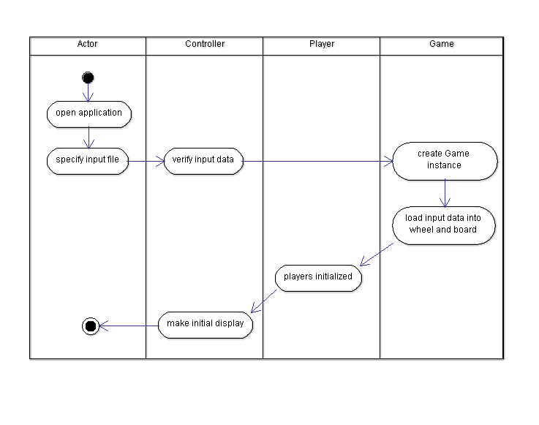This activity diagram simulates the Actor running the Wheel of Jeopardy! application, and the game setting itself up to be played.

Figure 2 Start Game Activity Diagram

## Switch Rounds Activity Diagram

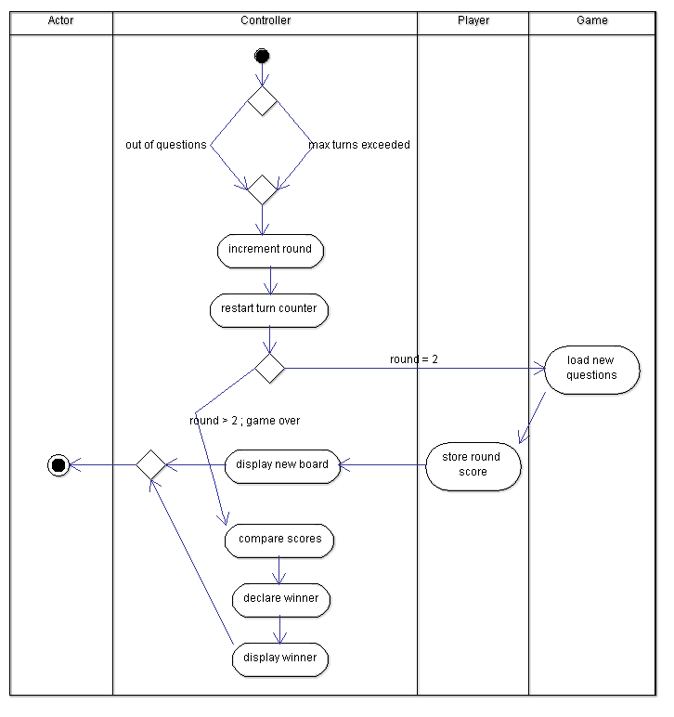This activity diagram simulates the controller realizing it is time to switch rounds during the game. This occurs due to one of two cases; all of the questions on the game Board have been answered, or the maximum number of turns in the round has been exceeded. The controller then checks which round the game is currently on, and either switches to the second round or ends the game.

Figure 3 Switch Rounds Activity Diagram

## Category Selection Activity Diagram

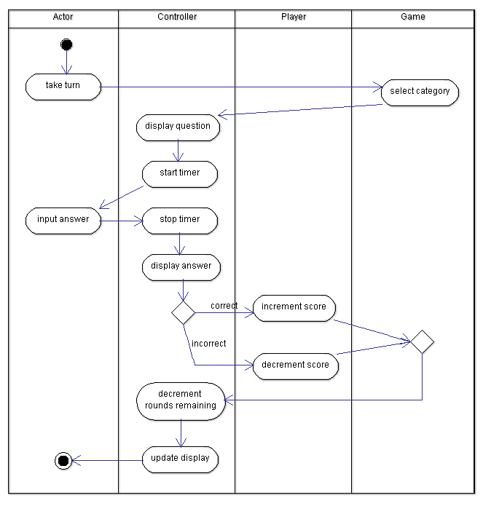This activity diagrams the Actor taking a turn and the Game spinning the Wheel, which lands on one of the question categories. The Actor must then answer the question, and their score is adjusted accordingly.

Figure 4 Category Selection Activity Diagram

## Free Turn Activity Diagram

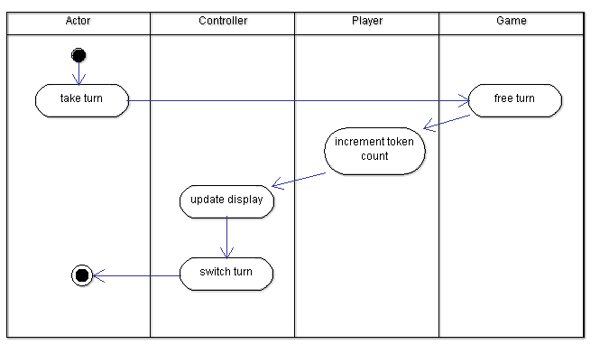This activity diagram simulates the Actor taking a turn and the Game spinning the Wheel, which lands on Free Turn and awards the current player with a token.

Figure 5 Free Turn Activity Diagram